Python Programming Lab Task Set

Set 4
- Q1. Create a function to reverse a list in Python. Use an AI tool to suggest alternative implementations. Test and compare the performance of each version.
Prompt: Write a python code for reverse a list by using user input function and compare the performance of each version.
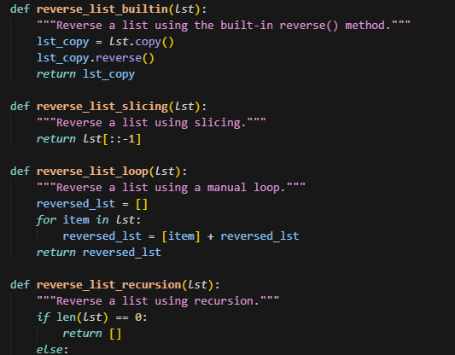
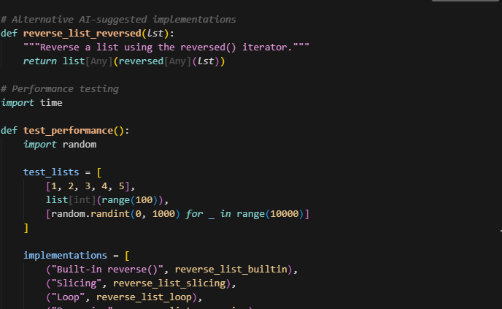
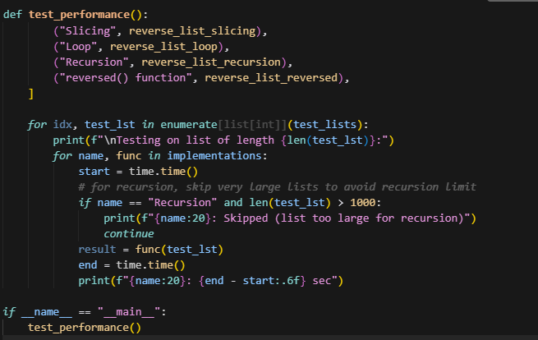
OUTPUT:
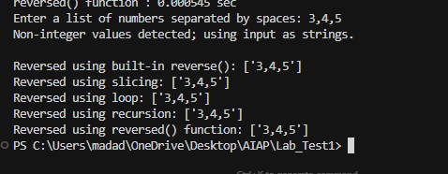
(Each question carries 5 marks)
- Q2. Design a few-shot prompt to guide an AI tool in writing code for a basic linked list with methods for insert and delete. Analyze the resulting code for correctness and completeness.
Prompt: Write a python code on a few-shot prompt to guide an AI tool in writing code for a basic linked list with methods for insert and delete by using user input function.
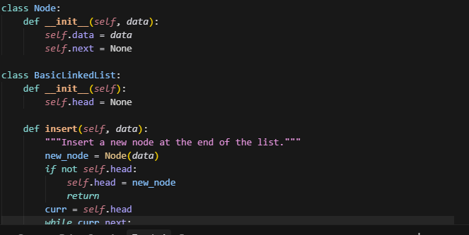
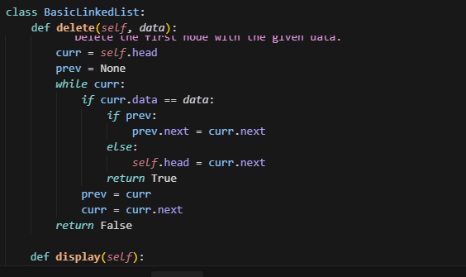
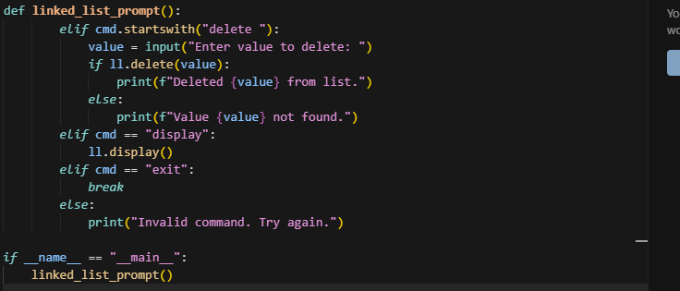
(Each question carries 5 marks)
OUTPUT:
